Домашняя работа №4

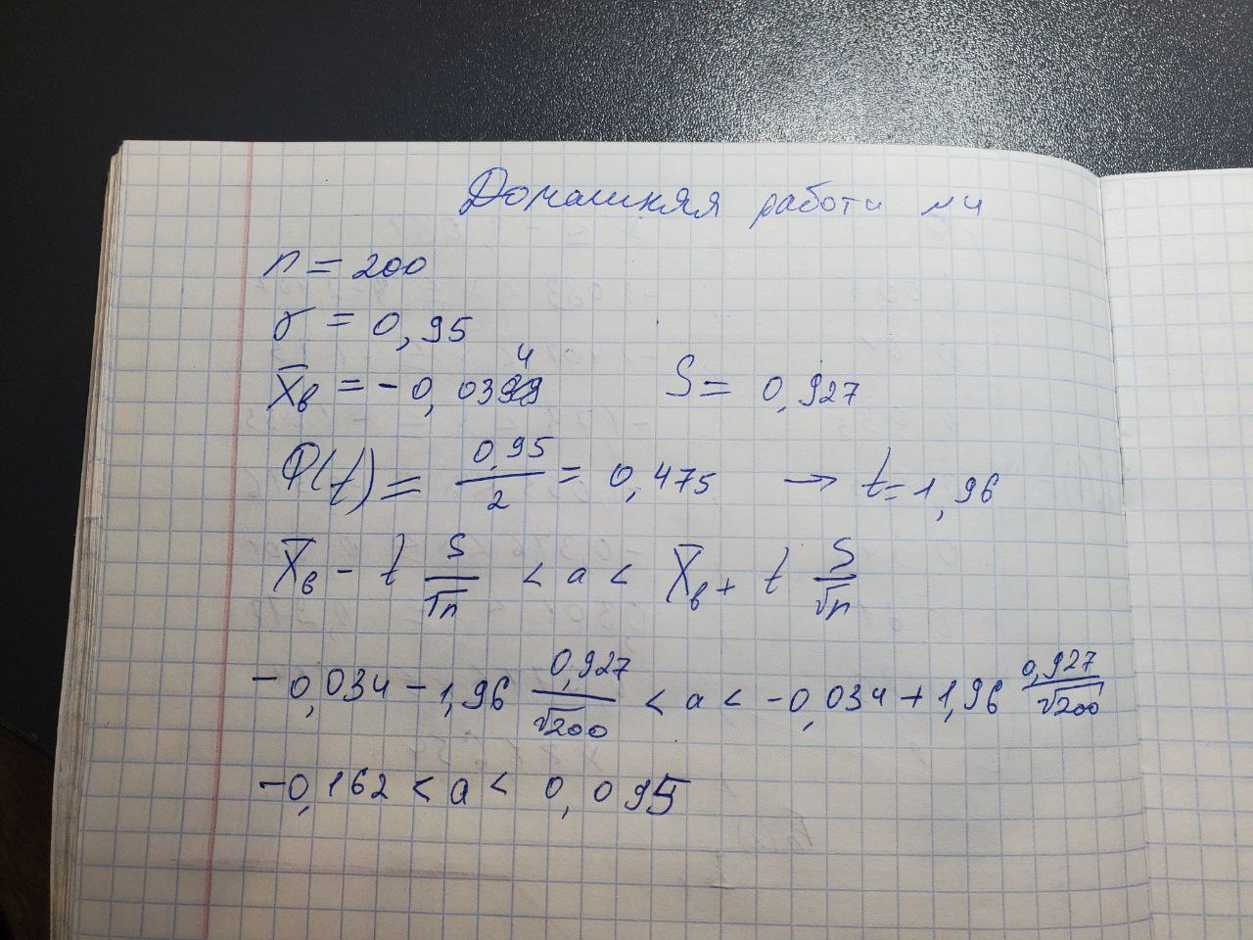

[МатСтат.xlsx](https://1drv.ms/x/s!As_qezOUkG09gb5R06eKjZCMEM_-3g?e=dg423G)